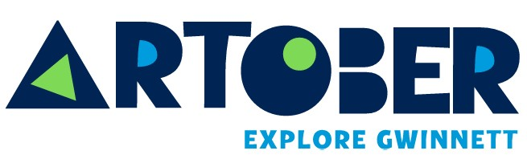

Explore Gwinnett Announces 10th Annual ARTober Gwinnett
Gwinnett County Marks a Decade of Celebrating Arts and Culture This October; Festivities to Include Pop-Up Art Installations, Interactive Experiences and Return of ‘Not Your Mother’s Art Fest’

GWINNETT COUNTY, Ga. (September 17, 2026) – Explore Gwinnett, the destination marketing organization for Gwinnett County, Ga, today announced details on its 10th annual ARTober Gwinnett, a monthlong celebration of the county’s vibrant arts and culture community. Beginning October 1st, Gwinnett County will transform into a living gallery with new pop-up art installations, interactive experiences and community events designed to make art more accessible and engaging. ARTober also marks the opening of the 2027 Gwinnett Creativity Fund (GCF) Project Grants.

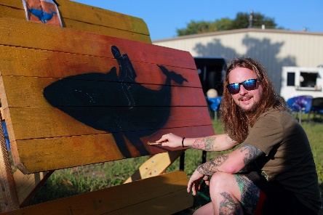
“For the last 10 years, ARTober has served as an incredible celebration of all things arts and culture across Gwinnett County, shining a spotlight on the artists, organizations and creative spaces that make our county such a dynamic place to live and visit,” said Madison Chucci, senior community development manager at Explore Gwinnett. “This year, we’re excited to take ARTober beyond traditional art and event spaces with a variety of new elements that bring creativity directly into the places where people live, work and explore.”

Project applications for the GCF 2027 grant cycle will open on October 1st, 2026. The GCF has awarded more than $1.5 million since it started in 2020 and aims to assist local non-profit arts and cultural organizations through placemaking and project-based grants. Applications are open through January 31st, 2027.

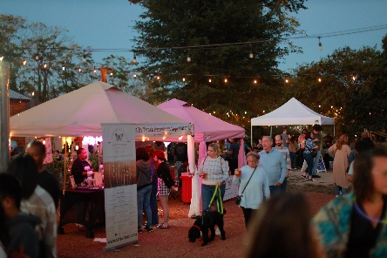
New this year, unique Mini Art Galleries will pop up at Peachtree Corners Town Green, Suwanee Circle and Eye Candy Art Studio in downtown Duluth, inviting residents and visitors to participate in a creative exchange by taking a piece of art, leaving a piece of art or donating art supplies for the next creator. Gwinnett County artist Max Eve will transform each mini gallery into a unique work of art, adding a colorful, interactive element to the community while making art more accessible to all. Mini Art Galleries will remain on display through October 31st.

ARTober will also bring a new temporary public art installation to Skin Alley in downtown Historic Norcross from October 1st through November 8th. Created in partnership with Dashboard and the City of Norcross, “GROW HERE” transforms an abandoned bank teller drive-through into an immersive garden designed by Lisette Correa, also known as ARRRTADDICT. The installation will feature dimensional sculptural flowers, oversized grass forms, mirrors and more.
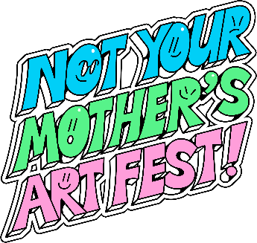
As part of the monthlong festivities, Explore Gwinnett will welcome back Not Your Mother’s Art Fest. ARTober’s marquee event will take place Friday, October 16th from 6 to 10 p.m. at Slow Pour Brewing in Lawrenceville. This year’s artwork was designed by Atlanta-based art director, graphic designer and illustrator Broly Su. Known for his bold, graffiti-inspired style and eccentric color palettes, Su’s work encapsulates the message of Not Your Mother’s Art Fest, celebrating non-traditional art styles and unconventional creativity. From live art demonstrations and hands-on workshops, the event pushes creative boundaries and invites attendees to experience art beyond the canvas.

“When creating this year’s artwork, my goal was to capture the dynamic, energetic spirit of Not Your Mother’s Art Fest while still staying true to my own style,” said Su. “This festival brings together people from all different backgrounds, so I wanted to create something that reflects that sense of connection and community. At the end of the day, it’s about creating something fun, unexpected and reflective of the energy people will experience at the festival.”

In addition to Not Your Mother’s Art Fest, ARTober Gwinnett will feature a line-up of vibrant events, inviting the community to paint, dance, photograph, taste and create alongside local artists. A full schedule of ARTober events is available here.

For more information on ARTober Gwinnett, visit ExploreGwinnett.org/ARTober or contact Madison@ExploreGwinnett.org. To learn more about the 2027 GCF Grants, visit GwinnettCreativityFund.com/Project-Grant.

For details on Explore Gwinnett, visit ExploreGwinnett.org. Stay up-to-date on the latest news by following @ExploreGwinnett on Instagram or ExploreGwinnett on Facebook.

MEDIA NOTE: Event graphics and hi-resolution photos can be found HERE, credit to be provided to Explore Gwinnett.

About Explore Gwinnett:
Explore Gwinnett serves as the official tourism organization of Gwinnett County, which consists of 17 suburban cities northeast of Downtown Atlanta. Its mission is to drive economic impact and position the county as a premier tourism destination by supporting more than 100 hotels and generating over $1 billion in annual visitor expenditures.

Gwinnett County boasts award-winning dining ranging from authentic Asian fare to southern delights, an abundance of shopping, arts programming, outdoor activities and more. Locals and tourists alike can explore various culinary offerings through innovative events including Gwinnett Burger Week and Seoul of the South™ Food Tours. Gwinnett County is a flourishing community for the creative economy, and Explore Gwinnett leads both the Gwinnett Creativity Fund and the Gwinnett Film Commission, supporting the counties thriving production ecosystem for film/television.

###

MEDIA CONTACT:
Kate Shelley, Hemsworth
630-215-9912 | ExploreGwinnettPR@HemsworthCommunications.com

