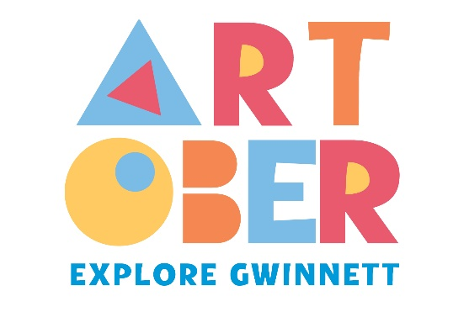

Explore Gwinnett Announces Ninth Annual ARTober Gwinnett
Gwinnett County Transforms Into a Living Gallery This October With 31 Days of Arts, Culture and Community Experiences – Including the Return of the Award-Winning Not Your Mother’s Art Fest

GWINNETT COUNTY, Ga. (October 6, 2025) – Explore Gwinnett, the official tourism organization of Gwinnett County, is thrilled to announce its ninth annual ARTober Gwinnett, a monthlong celebration of the county’s arts, culture and community. This month, Gwinnett County will transform into a living gallery as local artists, performers and cultural organizations bring their talents to stages, streets and unexpected spaces across the community. This year’s 31 days of programming includes the return of the award-winning Not Your Mother's Art Fest in Lawrenceville.

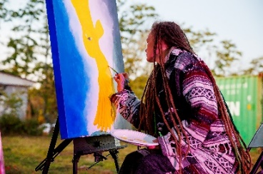
“ARTober is such a special time for Gwinnett because it gives residents and visitors the chance to experience our community’s creativity in so many unique ways,” said Madison Chucci, senior community development manager of Explore Gwinnett Tourism and Film. “After a successful inaugural celebration last year, we’re excited for Not Your Mother’s Art Fest to return and once again break the mold of the traditional art festival.”

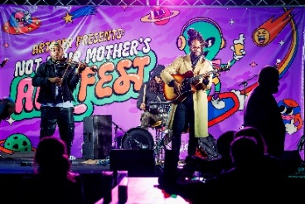
Named the 2025 Best New Event in the Southeast by the Southeast Festivals & Events Association, Not Your Mother’s Art Fest will take place on Friday, October 10, from 6 to 10 p.m. at Slow Pour Brewing. The free, family-friendly festival celebrates nontraditional art styles and unconventional creativity through immersive installations, live performances, street art, hands-on workshops and interactive experiences. From cutting-edge contemporary works to fresh takes on classic forms, Not Your Mother’s Art Fest spotlights diverse voices and underrepresented artists who are redefining what art can be. Hosted in partnership with the City of Lawrenceville and Slow Pour Brewing, the celebration blends creativity with community spirit, complemented by local craft beer, food and an inclusive atmosphere.

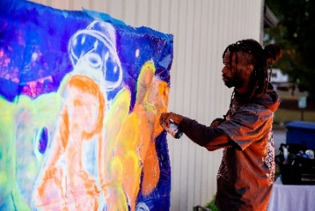
In addition to Not Your Mother’s Art Fest, ARTober Gwinnett will feature a lineup of events showcasing the depth and diversity of the county’s creative community. From live theater and poetry slams to music festivals, chalk art, haunted tours and public art, each day offers a new way to connect with creativity. A full list of ARTober events is available here.

“Our 2025 ARTober will be the biggest and most exciting yet,” said Lisa Anders, chief operating officer of Explore Gwinnett Tourism and Film. “As we enter our ninth year celebrating and elevating Gwinnett’s arts and cultural spaces, we’re proud to continue adding new ways for residents and visitors to experience the people, places and stories that shape the county’s vibrant creative community.”

ARTober Gwinnett will also kick off the Gwinnett Creativity Fund (GCF) 2026 grant cycle. Now in its seventh year, the GCF aims to enhance the county’s diverse cultural landscape by providing financial support to local arts and educational organizations through operational and project-based grants. Applications are open through January 15, 2026.

*MEDIA NOTE: Event graphics and images from last year’s inaugural Not Your Mother’s Art Fest are available HERE.

For more information on ARTober Gwinnett, visit ExploreGwinnett.org/ARTober or contact Madison@ExploreGwinnett.org. To learn more about the 2026 GCF Grants, visit GwinnettCreativityFund.com/Project-Grant.

For details on Explore Gwinnett, visit ExploreGwinnett.org. Stay up-to-date on the latest news by following @ExploreGwinnett on Instagram or ExploreGwinnett on Facebook.

About Explore Gwinnett:
Explore Gwinnett serves as the official tourism organization of Gwinnett County, which consists of 17 suburban cities northeast of Downtown Atlanta. Its mission is to drive economic impact and position the county as a premier tourism destination by supporting more than 100 hotels and generating over $1 billion in annual visitor expenditures.

Gwinnett County boasts award-winning dining ranging from authentic Asian fare to southern delights, an abundance of shopping, arts programming, outdoor activities and more. Locals and tourists alike can explore various culinary offerings through innovative events including Gwinnett Burger Week and Seoul of the South™ Food Tours. Gwinnett County is a flourishing community for the creative economy, and Explore Gwinnett leads both the Gwinnett Creativity Fund and the Gwinnett Film Commission, supporting the counties thriving production ecosystem for film/television.

###

MEDIA CONTACT:
Cameron Trice, Hemsworth
770-286-2207 | ExploreGwinnettPR@HemsworthCommunications.com

