Community members,

The Explore Gwinnett team was thrilled to host the Georgia Association for Convention and Visitors Bureau (GACVB) for its Annual Conference at the Gas South Convention Center this month. Themed “Cultural Crossroads” as a nod to Gwinnett County being one of the most diverse counties in the southeast, the conference experienced record attendance welcoming more than 250 hospitality and tourism industry members to Gwinnett County. The agenda included keynote speakers, professional development courses, advocacy meetings, and the opportunity to experience many of our amazing attractions across the county, visiting locations in Lawrenceville, Suwannee and Duluth.

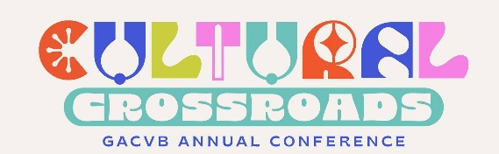
During the event, our very own Chief Operating Officer Lisa Anders said, “it is always our pleasure to be the host destination for any professional event, but it is particularly special to host leaders within our field to showcase why Gwinnett County’s hospitality industry is one of the best in the state.

One of the highlights of the conference was the GACVB Tourism Awards, which recognized outstanding organizations and individuals across nine categories. We are thrilled to announce that Lisa Anders was honored with the Paul Allen Leadership Award, which celebrates individuals who demonstrate outstanding leadership skills. Lisa’s nomination highlighted her unwavering guidance, including the 2024 expansion of her role to include overseeing the Gwinnett Sports Commission, which grew her team to more than a dozen employees. Over her 25 years with Explore Gwinnett, Lisa has played a pivotal role in driving tourism’s economic impact, surpassing $1 billion in expenditures and consistently leading metro Atlanta in hotel occupancy.

“Leadership is not about what your title is – it’s about one life influencing another in a positive fashion,” Lisa said, during her acceptance speech. “Leaders are not able to produce without being surrounded by excellence and I could not do my job without my team. They are simply the best, and it is my privilege to work alongside them to grow Explore Gwinnett’s tourism footprint.”

We commend Lisa for this incredible honor and congratulate the GACVB team for an outstanding event! Finally, we want to say a special thank you to Bitzel's Chocolate, Local Republic, Accent Creative Group, BAPS Shri Swaminarayan Mandir, Gas South District, Westin Duluth, Medieval Times, Jang Su Jang, Cafe Mixx, Honey Pig, Good Word Brewing, Eagle Rock Studios and City of Duluth for being outstanding partners and hosting conference attendees.

